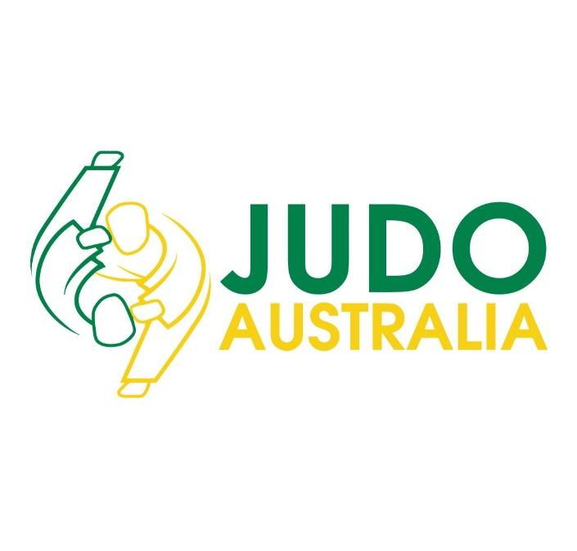

Board Search Statement
Date: Friday 29th August 2025

Background/Introduction
The Judo Federation of Australia (JA) is the National Sporting Organisation (NSO) with the purpose of facilitating and promoting Judo in Australia. Our vision is inspired by the Judo moral code to create safe, welcoming and fun experiences.
JA has the following strategic priorities, which are in line with the Australian Sports Commission Play Well Strategy:
- Empowering People and Organisations
- Driving Lifelong Involvement
- Activating Places and Spaces
- Building Connections
- Equitable Access
- Transforming Culture

The Board of Directors
JA is led by a skills-based board of elected and appointed directors. The Board’s role encompasses the governance of the organisation and to provide strategic leadership by way of:
- Formulating and implementing strategic direction: The Board set the long-term goals and strategies for JA.
- Determining policies: The Board establish policies relevant to the governance and performance of the organisation.
- Ensuring compliance: The Board ensure that JA complies with all legal requirements.
- Approving and monitoring the budget: The Board oversee the financial health of the organisation.
- Appointing and managing the GM’s: The Board are responsible for hiring and evaluating the performance of the GM’s.
- Maintaining stakeholder relationships: The Board manage relationships with key stakeholders, including government bodies and sponsors.
- Establishing Board committees: The Board create committees to handle specific functions and delegate tasks as necessary.
JA strives to support and promote excellence in board service through the recruitment of qualified, experienced directors from diverse backgrounds.
We want members of the JA Board to be advocates for Judo across all key strategic imperatives. We want people who can question and challenge constructively, who bring diverse views, who can influence others and find solutions. JA is committed to having a diverse and inclusive culture on our Board, in our organisation and in our sport.
Director positions are voluntary. Board meetings are held on a bi-monthly basis either online or in-person.
The Process
The Board Search Statement is to advise JA members and the broader community of the upcoming Director vacancies elections.
There is 1 position which will become vacant at the Annual General Meeting (AGM) Saturday, 18th October, 2025 with the position for a term of three (3) years.
The term of the following Director will expire at the AGM and is eligible to nominate for re-election to the position of Director:

- Lindsay Clement-Meehan

The incumbent Director has indicated they will not seek re-election.
The Board currently consists of 7 Director - 5 elected Directors, and 2 appointed Directors.
This vacancy will be filled member vote (where the voting members are affiliated State and Territory Organisations).

Eligibility
To be eligible for election a nominee must be;
- Endorsed by a Member Organisation.
- Agree and be bound by the JA Constitution and Policies.
- Not be an employee of JA or affiliated member organisation.

Skill set being sought
The specific Director skill sets sought for the Board will be determined based on JA’s current strategic priorities and the Board Skills Matrix of the continuing Board Directors.
Nominees will be requested to provide information as to how they meet the desired skills and experience (demonstrate suitability) for a position on the Board.
Given the current composition of the JA Board, JA encourages candidates with strength in either:
- Finance
- Human Resources
- Communications and Marketing to nominate.
JA is committed to diversity and creating equal opportunities for women in sports governance. Women are strongly encouraged to nominate at this time.

Call for nominations
JA has called for nominations for 1 vacancy prior to the AGM. This has been communicated by the GMP via a Notice of AGM and Call for Nominations which is advertised on www.ausjudo.com.au, sent to voting members and shared widely across media channels and to Director Registries such as Australian Institute of Company Directors, SportAUS National Sports Directorship registry, Women on Boards, etc.
The term of the Board Director vacancies is 3 years and Directors are eligible for re-election.
If you are interested, please respond through the call for nominations process and complete the required nomination forms and supply any additional information as requested (e.g. cover letter, CV/resume, Consent to Act as a Director form, etc)
Nominations close COB 17th September 2025 and must be submitted to Gareth Watkins gwatkins@ausjudo.com.au and contact number +61 0408 684 911.

Consideration and review of the nomination
The Company’s People and Culture Committee (PCC) is responsible for the assessment of all applications and determination of those persons considered eligible.
The PCC consists of:
  - One (1) Independent Chair
  - One (1) JA Board Member; and
  - One (1) Member Association Representative

The PCC may put forward recommendations for the position of Director of the JA Board, or rank and recommend candidates to the voting members. There will be no opportunity for appeal in respect of the assessment undertaken by the PCC. Applicants will be notified regarding whether their application for nomination has been deemed eligible by no later than Friday, 26th September 2025.

For all enquiries, please contact Gareth Watkins gwatkins@ausjudo.com.au or call +61 0408 684 911.

